E-Commerce Website for Clothing Shop
using HTML, CSS and PHP
Abstract
The E-Commerce Clothing Website is designed to provide an efficient and user-friendly online shopping experience, catering to modern fashion trends and consumer preferences. This platform enables seamless browsing, product selection, and secure transactions for customers looking to purchase clothing items such as shirts, t-shirts, pants, and combo outfits.

The system incorporates real-time cart functionality using local storage, ensuring smooth shopping without requiring repeated logins. The website features a dynamic product catalog, filtering and search options, and an intuitive UI/UX design to enhance the customer experience. Additionally, secure payment integration ensures reliability for online transactions.

A key feature of this project is personalized recommendations and inventory management, allowing customers to discover relevant products based on browsing history while helping retailers optimize stock levels. Future enhancements may include AI-driven fashion suggestions, mobile app integration, and live customer support to further improve engagement and sales.

By leveraging modern web technologies (HTML, CSS, JavaScript, PHP, and MySQL), this platform aims to revolutionize the online fashion shopping experience, providing convenience, security, and efficiency for both customers and businesses.

CHAPTER 1
INTRODUCTION
The E-Commerce Clothing Website, "Yuv Clothing," is a comprehensive online shopping platform designed to cater to the evolving fashion needs of consumers. In the digital age, online shopping has transformed the retail industry by providing convenience, accessibility, and a wide range of choices to customers. The emergence of e-commerce platforms has enabled businesses to reach a broader audience while offering customers the ability to browse, select, and purchase products from the comfort of their homes.

The primary objective of this website is to bridge the gap between fashion retailers and customers by offering a user-friendly, secure, and feature-rich online shopping experience. The platform specializes in trendy fashion for Gen Z and includes an extensive collection of shirts, t-shirts, pants, and combo outfits from various brands. Customers can explore product categories, view high-quality images, check ratings and reviews, and make informed purchase decisions.

The E-Commerce Clothing Website integrates essential features such as real-time cart updates, secure payment gateways, and seamless order tracking to enhance the overall shopping experience. Additionally, the platform employs modern web technologies like HTML, CSS, JavaScript, PHP, and MySQL to ensure smooth navigation, fast loading times, and a responsive interface across all devices.

Key responsibilities and functions of the e-commerce clothing website include:
- Product Listings – Displaying a variety of clothing items with images, descriptions, prices, and customer reviews.
- Real-Time Cart Management – Enabling customers to add, update, and remove items seamlessly before checkout.
- Secure Payment Integration – Supporting multiple payment options such as credit/debit cards, UPI, and net banking.
- User Authentication – Allowing customers to create accounts, log in, and track their orders.
- Search and Filtering Options – Helping users find products based on categories, brands, and price range.
- Order Processing & Tracking – Providing real-time updates on order status, shipment tracking, and estimated delivery dates.
- Discounts and Promotions – Offering seasonal sales, discount codes, and combo deals to attract more customers.
- Customer Reviews and Ratings – Enabling users to leave feedback and rate products for quality assurance.
- Personalized Recommendations – Suggesting relevant products based on browsing history and preferences.
- Inventory Management – Ensuring product availability and updating stock levels in real-time.
- Admin Panel – A dashboard for managing product listings, processing orders, and handling customer inquiries.
- Mobile Responsiveness – Optimizing the platform for seamless browsing on mobile devices.
- Customer Support & FAQs – Providing assistance through live chat, email, and a knowledge base for common queries.

The E-Commerce Clothing Website serves as a dynamic link between retailers and customers, revolutionizing the shopping experience through technology-driven solutions. By offering a convenient, secure, and engaging platform, it enhances customer satisfaction while driving business growth in the competitive e-commerce landscape.

CHAPTER 2
ORGANISATION PROFILE
Yuv Clothing is a modern and innovative e-commerce brand specializing in stylish and high-quality fashion apparel. Founded with the vision of making trendy fashion accessible to all, Yuv Clothing is committed to delivering an exceptional online shopping experience with a seamless and user-friendly interface. The company brings together a collection of shirts, t-shirts, pants, and combo outfits, catering to the fashion needs of Gen Z and beyond.

The brand aims to blend fashion with technology, offering a wide range of clothing products through an interactive digital platform that prioritizes customer satisfaction, affordability, and style. Yuv Clothing ensures that every customer experiences the latest trends with high-quality fabrics and premium designs.

Establishment and Infrastructure
Founded in 2022, Yuv Clothing operates its headquarters and fulfillment center in Trichy, India—a city known for its thriving textile and fashion industry. The company leverages advanced logistics and a state-of-the-art inventory management system to ensure fast and efficient delivery of products.
The e-commerce platform is powered by the latest web technologies and is optimized for fast browsing, real-time cart management, and secure transactions. With a focus on seamless order fulfillment, Yuv Clothing collaborates with top-tier delivery partners to provide nationwide and international shipping services.

Vision
Our vision is to redefine the online fashion retail industry by offering affordable, stylish, and high-quality apparel with a hassle-free shopping experience. We aspire to be a globally recognized fashion brand that sets new standards in customer satisfaction, convenience, and innovation.

Mission
Our mission is to:
- Provide high-quality fashion at competitive prices.
- Enhance customer experience with a seamless and secure shopping platform.
- Stay ahead of fashion trends and bring the latest designs to our customers.
- Ensure sustainability by promoting eco-friendly packaging and ethical sourcing.
- Leverage technology to offer personalized shopping recommendations and real-time inventory updates.

Location
Headquarters: Trichy, India
Warehouses & Fulfillment Centers: Trichy
Through its dedication to quality, innovation, and customer satisfaction, Yuv Clothing continues to make a mark in the online fashion industry, offering stylish apparel that fits every lifestyle

CHAPTER 3
SYSTEM CONFIGURATION
3.1 HARDWARE CONFIGURATION
- Processors: Intel® Core™ i5 processor 4300M at 2.60 GHz or 2.59 GHz (1 socket, 2 cores, 2 threads per core), 8 GB of DRAM
- Disk space: 320 GB
- Operating systems: Windows® 11, macOS*, and Linux*
3.2 SOFTWARE CONFIGURATION
- Server Side : PHP
- Client Side : HTML, CSS and Java Script
- IDE : Dreamweaver 8
- Back end : MySQL 5.
- Server : Xampserver 2i

CHAPTER 4
SOFTWARE FESTURES
PHP 8.1
The PHP Hypertext Preprocessor (PHP) is a programming language that allows web developers to create dynamic content that interacts with databases. PHP is basically used for developing web-based software applications. This tutorial helps you to build your base with PHP.

PHP is a flexible, dynamic language that supports a variety of programming techniques. It has evolved dramatically over the years, notably adding a solid object-oriented model in PHP 5.0 (2004), anonymous functions and namespaces in PHP 5.3 (2009), and traits in PHP 5.4 (2012).
Object-oriented Programming
PHP has a very complete set of object-oriented programming features including support for classes, abstract classes, interfaces, inheritance, constructors, cloning, exceptions, and more.
Functional Programming
PHP supports first-class functions, meaning that a function can be assigned to a variable. Both user-defined and built-in functions can be referenced by a variable and invoked dynamically. Functions can be passed as arguments to other functions (a feature called Higher-order Functions) and functions can return other functions.
Standard PHP Library
The Standard PHP Library (SPL) is packaged with PHP and provides a collection of classes and interfaces. It is made up primarily of commonly needed data structure classes (stack, queue, heap, and so on), and iterators which can traverse over these data structures or your own classes which implement SPL interfaces.
Command Line Interface
PHP was created to write web applications, but is also useful for scripting command line interface (CLI) programs. Command line PHP programs can help automate common tasks like testing, deployment, and application administration.
Back End: MySQL
MySQL tutorial provides basic and advanced concepts of MySQL. Our MySQL tutorial is designed for beginners and professionals. MySQL is a relational database management system based on the Structured Query Language, which is the popular language for accessing and managing the records in the database. MySQL is open-source and free software under the GNU license. It is supported by Oracle Company. MySQL database that provides for how to manage database and to manipulate data with the help of various SQL queries. These queries are: insert records, update records, delete records, select records, create tables, drop tables, etc. There are also given MySQL interview questions to help you better understand the MySQL database.

MySQL is currently the most popular database management system software used for managing the relational database. It is open-source database software, which is supported by Oracle Company. It is fast, scalable, and easy to use database management system in comparison with Microsoft SQL Server and Oracle Database. It is commonly used in conjunction with PHP scripts for creating powerful and dynamic server-side or web-based enterprise applications. It is developed, marketed, and supported by MySQL AB, a Swedish company, and written in C programming language and C++ programming language. The official pronunciation of MySQL is not the My Sequel; it is My Ess Que Ell. However, you can pronounce it in your way. Many small and big companies use MySQL. MySQL supports many Operating Systems like Windows, Linux, MacOS, etc. with C, C++, and Java languages.
WampServer
WampServer is a Windows web development environment. It allows you to create web applications with Apache2, PHP and a MySQL database. Alongside, PhpMyAdmin allows you to manage easily your database.

WAMPServer is a reliable web development software program that lets you create web apps with MYSQL database and PHP Apache2. With an intuitive interface, the application features numerous functionalities and makes it the preferred choice of developers from around the world. The software is free to use and doesn’t require a payment or subscription.
Bootstrap 4
Bootstrap is a free and open-source tool collection for creating responsive websites and web applications. It is the most popular HTML, CSS, and JavaScript framework for developing responsive, mobile-first websites.

It solves many problems which we had once, one of which is the cross-browser compatibility issue. Nowadays, the websites are perfect for all the browsers (IE, Firefox, and Chrome) and for all sizes of screens (Desktop, Tablets, Phablets, and Phones). All thanks to Bootstrap developers -Mark Otto and Jacob Thornton of Twitter, though it was later declared to be an open-source project.
Easy to use: Anybody with just basic knowledge of HTML and CSS can start using Bootstrap
Responsive features: Bootstrap's responsive CSS adjusts to phones, tablets, and desktops
Mobile-first approach: In Bootstrap, mobile-first styles are part of the core framework
Browser compatibility: Bootstrap 4 is compatible with all modern browsers (Chrome, Firefox, Internet Explorer 10+, Edge, Safari, and Opera)
Dreamviewer
Macromedia® Dreamweaver® 8 from Adobe is the industry-leading web development tool that lets you efficiently design, develop and maintain standards-based websites and applications. Dreamweaver 8 provides a powerful combination of visual layout tools, application development features, and code editing support.

Dreamweaver 8 includes many new features to help you create and maintain websites that range from basic home pages to advanced applications that support best practices and the latest technologies.
Features of Dreamweaver:
The features of Dreamweaver make it a versatile web editing tool, some of the features of Dreamweaver are as follows:
- Dreamweaver supports multiple web and programming languages including HTML, JSP, Cascading Style Sheets (CSS), Active Server Pages (ASP), PHP, Extensible Markup language (XML), and many more.
- Dreamweaver is working on both types of operating systems like MAC OS and Windows.
- In Dreamweaver, you can design both using visually and by using code.
- Dreamweaver allows us to use and test all the popular content management system like Drupal, WordPress, and Joomla. It allows you to see your page in action.
- Dreamweaver provides you with coding assistance.
- It allows you to display the CSS box model without having to know the way to code the stylesheets manually.
- Dreamweaver provides a layer option with the help of which both images and text can be placed at any position on the web page.
- Dreamweaver offers a design palette with a large number of color options. The user can either use the default color available or make its own composition.
- Dreamweaver also provides a publishing tool that helps you to easily manage your files, both locally and on your web server.
- Dreamweaver includes very powerful features to help web developers manage all the related files for a site, post those files to a remote web server, and keep the local files and the files on the remote server synchronized.
- Dreamweaver facilities a rich set of features in a single program capable f handling the most advanced web design and development projects for example: from a simple home page to a large complex project.

CHAPTER 5
PROJECT DESCRIPTION
5.1 Overview of the Project
The project "Design and Development of an E-Commerce Clothing Website" aims to create a modern, user-friendly, and efficient online shopping platform that enhances the shopping experience for customers looking for trendy fashion apparel. This platform facilitates the seamless browsing, selection, and purchasing of clothing items, ensuring convenience and accessibility for users.

With the rise of e-commerce and online retail, consumers demand a secure, visually appealing, and highly functional website to purchase clothing. The Yuv Clothing e-commerce platform is designed to meet these demands by offering a robust and interactive interface. The system provides functionalities such as real-time cart updates, secure payments, order tracking, product recommendations, and an intuitive user dashboard.
The website incorporates advanced filtering and search options, allowing users to browse through an extensive collection of shirts, t-shirts, pants, and combo outfits based on size, color, brand, and price. Additionally, the platform integrates a secure payment gateway, AI-driven recommendations, and mobile responsiveness to provide a seamless shopping experience.

This project aims to bridge the gap between traditional retail and modern digital shopping by offering a feature-rich e-commerce solution that caters to a wide audience, from casual buyers to fashion enthusiasts.

5.2 Problem Statement
The traditional clothing retail system has several limitations that impact customer experience and business growth. The challenges faced in conventional shopping include:
- Limited Availability of Products – Physical stores have space constraints, limiting product variety. Customers may not always find their desired items.
- Lack of Convenience – Customers need to visit multiple stores to find the perfect clothing, leading to time-consuming shopping experiences.
- Inconsistent Product Information – In physical retail, customers lack detailed product descriptions, reviews, and comparisons.
- Limited Payment Options – Traditional stores may not support various payment methods such as digital wallets, UPI, or installment-based payments.
- No Personalized Shopping Experience – Physical stores lack personalized recommendations based on customer preferences and past purchases.
- Manual Inventory Management – Traditional retailers face difficulties in managing inventory efficiently, leading to stock shortages or overstocking issues.
- Inefficient Customer Support – Customers often struggle with returns, exchanges, and inquiries due to the lack of a dedicated support system.
The E-Commerce Clothing Website addresses these issues by providing an online platform that enables smooth browsing, order placement, secure payments, and hassle-free customer service.

5.2.1 Web Technology
The platform is developed using modern web technologies to ensure a high-performance, scalable, and responsive website. The core technologies used include:
- HTML (HyperText Markup Language) – Defines the structure of web pages and displays product images, descriptions, and interactive elements.
- CSS (Cascading Style Sheets) – Enhances the visual appeal by managing the layout, fonts, colors, and animations.
- JavaScript – Adds interactivity such as real-time cart updates, product filtering, and dynamic search.
- PHP (Server-Side Scripting) – Handles user authentication, order processing, and database interactions.
- MySQL (Database Management System) – Stores user details, product data, order history, and payment records.
- Bootstrap – Ensures mobile responsiveness and a clean, intuitive UI.
- APIs (Application Programming Interfaces) – Integrates payment gateways, shipping services, and AI-powered recommendations.
- Cloud Hosting – Ensures high availability and scalability for handling large user traffic.

5.2.2 Aim and Objective
Aim
The primary aim of the E-Commerce Clothing Website is to develop a secure, scalable, and feature-rich platform that enhances online shopping convenience for customers while providing businesses with an efficient retail solution.
Objectives
- To create a visually appealing and easy-to-navigate e-commerce platform for clothing.
- To integrate real-time cart functionality for seamless shopping.
- To develop a secure payment system supporting multiple payment methods.
- To enable order tracking, return policies, and customer support services.
- To implement product filtering, sorting, and AI-driven recommendations for a personalized shopping experience.
- To offer an inventory management system for businesses to keep track of stock levels and avoid shortages.
- To ensure mobile responsiveness, allowing users to shop conveniently from any device.
- To improve customer retention through loyalty programs, discounts, and offers.
- To implement SEO optimization for better visibility and organic traffic.
5.3 Modules Description
The E-Commerce Clothing Website is built with various modules to ensure seamless functionality for customers, administrators, and vendors.
User Roles and Modules:
1. Customer Module
- Register/Login – Users can create an account and log in securely.
- Browse Products – Customers can explore clothing categories, view product details, and check availability.
- Search and Filter – Advanced filters allow customers to find products based on brand, price, color, and size.
- Add to Cart – Users can add products to their cart and update quantities.
- Wishlist Feature – Customers can save items for future purchases.
- Checkout and Secure Payment – Multiple payment options including UPI, Credit/Debit Cards, and Wallets.
- Order Tracking – Real-time updates on order status and delivery progress.
- Product Reviews and Ratings – Customers can provide feedback on purchases.
- Returns & Refunds – Easy return and refund options for unsatisfactory orders.
2. Admin Module
- User Management – Admins can manage customer accounts, vendors, and delivery partners.
- Product Management – Adding, updating, and removing product listings with descriptions and images.
- Order Management – Viewing, processing, and managing order statuses.
- Inventory Management – Keeping track of stock availability.
- Discounts & Promotions – Managing offers, coupon codes, and seasonal sales.
- Analytics & Reports – Tracking sales, customer behavior, and product popularity.
3. Vendor Module
- Vendor Registration – Sellers can sign up and list their clothing products.
- Inventory & Order Management – Vendors manage stock levels and track orders.
- Earnings & Payouts – Dashboard for tracking sales and earnings.
4. Payment Module
- Secure Payment Processing – Supports online transactions via Razorpay, PayPal, Stripe, UPI, and Net Banking.
- Invoice Generation – Customers receive order invoices for their purchases.
- Refund Management – Processing refunds and cancellations securely.
5. Customer Support Module
- Live Chat Assistance – AI-powered chatbot and human support for inquiries.
- FAQs and Help Center – Provides self-service support for common issues.
- Email and Phone Support – Direct customer service support for returns, payments, and general queries.

CHAPTER 6
SYSTEM ANALYSIS
6.1 Existing System
The traditional clothing retail system primarily relies on physical stores and offline shopping methods, which pose several limitations in terms of convenience, accessibility, and efficiency. Some of the common challenges faced in traditional retail include:
- Limited Product Availability – Physical stores have space constraints, leading to a restricted product catalog. Customers may not find the exact clothing style, size, or color they are looking for.
- Inconvenience of In-Store Shopping – Customers must visit stores physically, which can be time-consuming and inconvenient, especially in busy urban areas or during extreme weather conditions.
- Manual Inventory Management – Stock updates and inventory tracking in physical stores are often handled manually, leading to overstocking, shortages, or errors.
- Lack of Personalized Shopping Experience – Unlike e-commerce platforms, traditional stores do not provide tailored product recommendations based on customer preferences or browsing history.
- Limited Payment Options – Many retail stores do not support multiple payment methods such as digital wallets, UPI, or installment-based payments, making transactions less flexible.
- Geographical Restrictions – Customers residing in remote areas may have limited access to high-quality fashion choices.
- Higher Operational Costs – Running physical stores requires significant operational costs such as rent, utilities, and staffing, which often result in higher product prices.
- Inefficient Customer Support – Customers often face difficulties in returns, exchanges, and post-purchase assistance, as traditional retail lacks an integrated support system.
- Lack of Data-Driven Insights – Physical stores do not collect and analyze customer preferences, making it difficult for retailers to optimize their product offerings based on trends.
Disadvantages of the Existing System:
- Limited Accessibility – Customers are restricted to store hours and locations.
- Time-Consuming Shopping – Browsing multiple stores to compare options can be exhausting.
- No Real-Time Product Availability Updates – Customers often visit stores only to find their desired item is out of stock.
- Lack of Customer Engagement – No loyalty programs, targeted offers, or personalized shopping experiences.
- Manual Order and Billing Process – Slower checkouts and dependency on cash transactions.
- Higher Overheads – Rent, staff salaries, and operational expenses make traditional retail costly.
- Limited Marketing Reach – Store promotions are usually restricted to local advertising, reducing customer acquisition.
- No Seamless Return & Refund System – Customers struggle with the hassle of offline returns.
Due to these shortcomings, modern retailers are shifting towards e-commerce platforms to provide a better shopping experience, increase reach, and optimize business operations.

6.2 Proposed System
The proposed E-Commerce Clothing Website, "Yuv Clothing," is a modern online fashion platform designed to eliminate the inefficiencies of traditional retail and enhance the shopping experience through technology-driven solutions. The platform integrates real-time inventory tracking, AI-driven product recommendations, seamless checkout processes, and secure payment gateways to offer a superior customer experience.
Key Features of the Proposed System:
- Comprehensive Product Listings – Customers can browse a vast collection of shirts, t-shirts, pants, and combos with detailed descriptions, images, and reviews.
- Real-Time Cart Management – Users can add, remove, and update items in their cart before purchasing.
- Secure Payment Integration – Multiple payment options, including Credit/Debit Cards, UPI, Net Banking, and Digital Wallets, ensure secure transactions.
- Order Tracking System – Customers receive real-time updates on order status, shipment tracking, and estimated delivery times.
- Advanced Search and Filters – Users can refine searches by category, brand, price range, size, color, and customer ratings.
- AI-Driven Recommendations – Personalized product suggestions based on user browsing history and preferences.
- Easy Returns and Refunds – Customers can initiate returns effortlessly and receive refunds promptly.
- User Registration & Profile Management – Customers can create accounts to track orders, save favorites, and manage shipping addresses.
- Discounts & Loyalty Programs – Seasonal sales, promo codes, and exclusive discounts for registered users.
- Vendor Dashboard – Sellers can manage product listings, pricing, inventory, and sales analytics.
- SEO Optimization – Ensures higher search engine rankings to attract more online shoppers.
- Mobile-Friendly & Responsive Design – Provides a seamless shopping experience on smartphones, tablets, and desktops.
- 24/7 Customer Support – Integrated live chat, email support, and FAQs for resolving user queries.
Advantages of the Proposed System:
✅ Convenience – Customers can shop from anywhere at any time without visiting a physical store.
✅ Expanded Product Range – No limitations on storage or shelf space like traditional stores.
✅ Global Reach – Allows businesses to sell products nationwide and internationally.
✅ Personalized Shopping – AI-based recommendations and targeted promotions improve user experience.
✅ Efficient Order Processing – Automated order confirmation, tracking, and inventory updates ensure smooth transactions.
✅ Secure Transactions – Encrypted payment gateways protect users’ financial data.
✅ Cost-Effectiveness – Eliminates physical store expenses, reducing product costs for customers.
✅ Enhanced Marketing Strategies – Digital marketing, social media promotions, and email campaigns increase customer engagement.
✅ Real-Time Customer Feedback – Customers can rate and review products, helping businesses improve their offerings.
✅ Eco-Friendly Approach – Reduces paper-based transactions and carbon footprint by minimizing in-store visits.

The proposed system not only enhances operational efficiency but also transforms the shopping experience by offering accessibility, variety, and security, making it the ideal fashion e-commerce solution.

CHAPTER 7
SYSTEM DESIGN

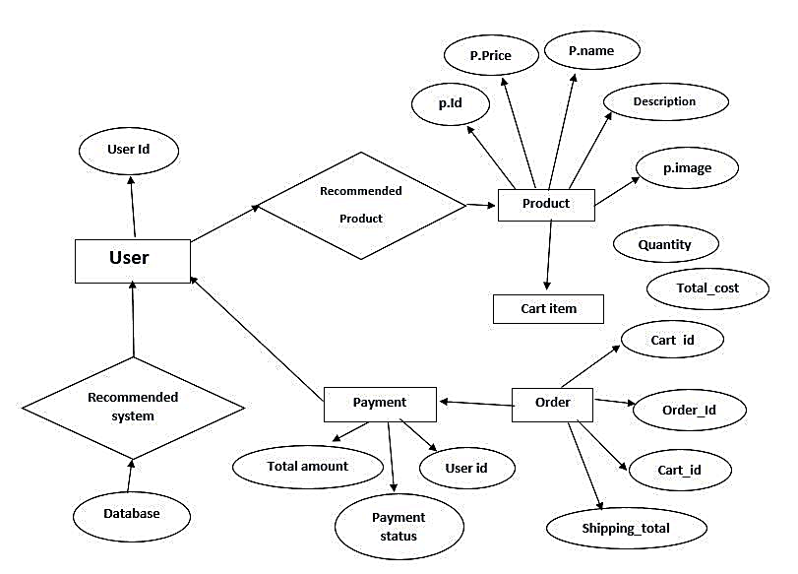

DFD Diagram

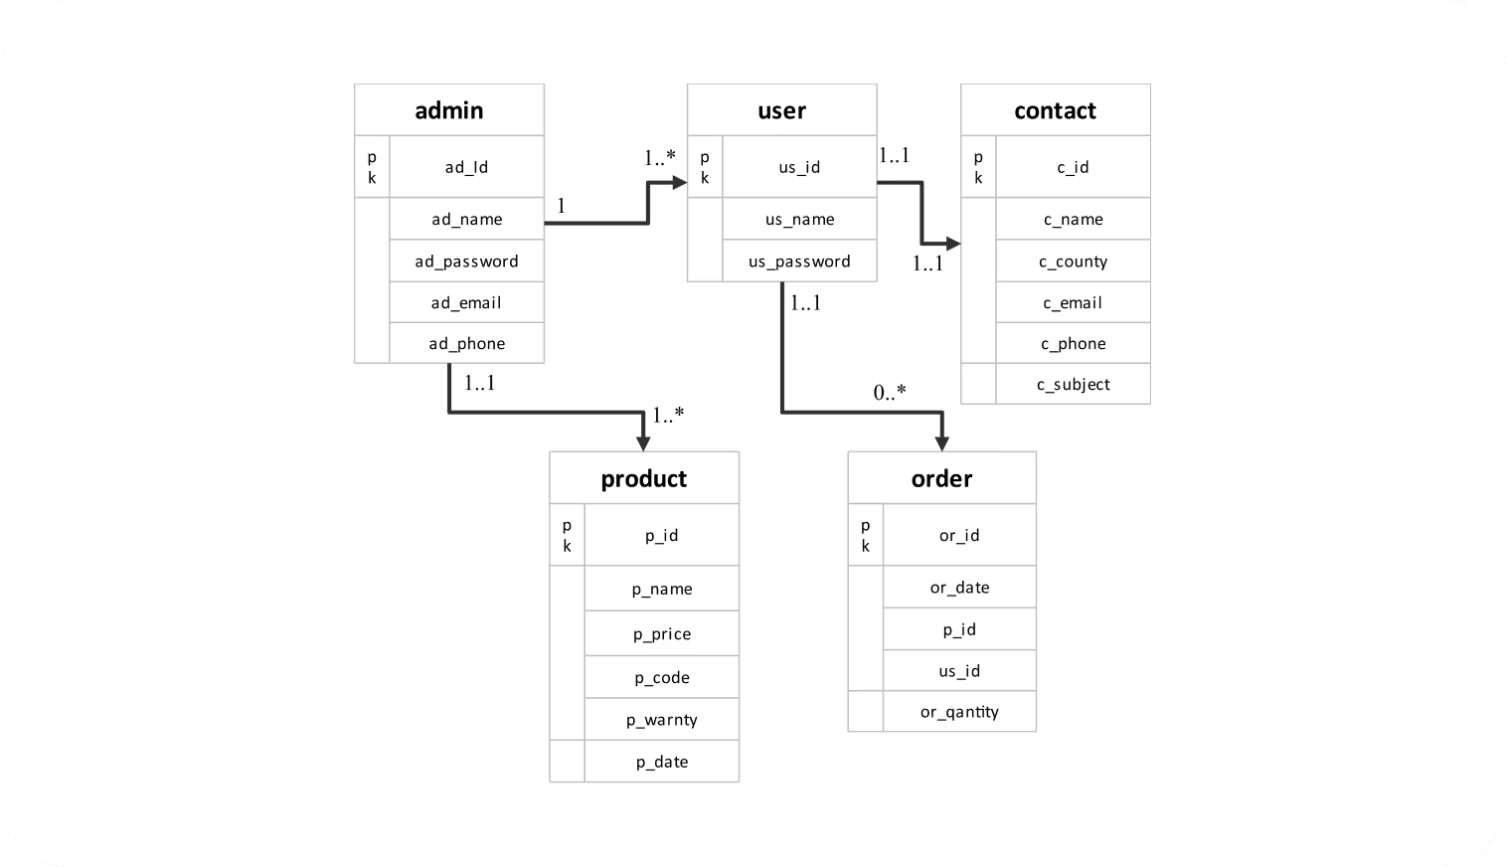

7.2. Data Base Design
Placement Cell

Table structure for table ci_admin
Field Name | Data Type | Constraints | Description
Mobile_no | varchar(20) | Not Null | Mobile Number
password | varchar(20) | Not Null | Password

Table structure for table ci_attendance
Field Name | Data Type | Constraints | Description
Name | int(11) | Not Null | Full Name
D.O.B | varchar(20) | Not Null | Date of Birth
Mobile_no | int(11) | Primary key | Mobile Number
Address | varchar(20) | Not Null | Address
Pin_code | varchar(20) | Not Null | Pin code

Table structure for table ci_department
Field Name | Data Type | Constraints | Description
Mobile_no | int(11) | Primary key | Mobile Number
New password | varchar(30) | Not Null | New password

Modules Description
- The "Design and Development of an E-Commerce Clothing Website" system is a web-based application that provides a platform for customers, sellers, administrators, and delivery personnel to interact with each other for the purpose of online shopping, order fulfillment, and business management.
- The system has four user roles: Customer, Seller, Admin, and Delivery Personnel. Each role has different functionalities and permissions as described below:
Customer
- Customers have access to the following functionalities:
- Register: Customers can create an account by providing details such as name, email, password, and shipping address.
- Login: Customers can log in to the system using their credentials.
- Update Profile: Customers can update their profile information, including personal details, contact information, and delivery addresses.
- Browse Products: Customers can explore the product catalog, view detailed descriptions, prices, and availability.
- Search & Filter Products: Customers can search for specific items and apply filters based on categories, price range, size, and brand.
- Add to Cart: Customers can add products to their shopping cart for future purchase.
- Manage Cart: Customers can update quantities or remove items from their cart.
- Checkout & Payment: Customers can proceed to checkout, choose a payment method, and complete their purchase.
- Track Orders: Customers can view the status of their orders, including order processing, shipping, and delivery updates.
- View Order History: Customers can access their previous orders and re-order products if needed.
- Write Reviews & Ratings: Customers can provide feedback on purchased products.
- Contact Support: Customers can reach out to customer support for any queries or issues related to their orders.

Seller
- Sellers have access to the following functionalities:
- Register: Sellers can create an account by providing business details, including store name and contact information.
- Receive Registration Approval: The Admin must approve a seller’s registration before they can access the system.
- Login: Sellers can log in to the system after approval.
- Manage Store Profile: Sellers can update their business details and branding information.
- Add & Manage Products: Sellers can add new products, update product details, stock levels, and pricing.
- View Orders: Sellers can see orders placed by customers for their products.
- Process Orders: Sellers can manage order fulfillment, update shipping status, and prepare packages for delivery.
- Handle Returns & Refunds: Sellers can manage customer return requests and issue refunds if applicable.
- Analyze Sales Reports: Sellers can view reports on product performance, sales trends, and customer behavior.
Admin
- The Admin has access to the following functionalities:
- Register/Login: The Admin can create an account and log in to the system.
- Approve Seller Registrations: The Admin can review and approve or reject seller registration requests.
- Manage Users: The Admin can manage customers, sellers, and delivery personnel accounts.
- Manage Product Categories: The Admin can create and organize product categories for easy browsing.
- Oversee Order Processing: The Admin can monitor the order process from purchase to delivery.
- Resolve Disputes: The Admin can handle customer complaints, refund disputes, and quality issues.
- Manage Discounts & Promotions: The Admin can create site-wide promotions, discount codes, and seasonal sales.
- Analyze System Reports: The Admin can generate reports on sales, revenue, customer engagement, and inventory levels.
- Handle Website Content: The Admin can update banners, advertisements, and featured products on the homepage.
Delivery Personnel
- Delivery personnel have access to the following functionalities:
- Register: Delivery personnel can create an account by providing personal details and work availability.
- Receive Registration Approval: The Admin must approve a delivery personnel’s registration before they can access the system.
- Login: Delivery personnel can log in to the system after approval.
- View Assigned Orders: Delivery personnel can see a list of orders assigned for delivery.
- Update Delivery Status: Delivery personnel can update the status of deliveries (e.g., out for delivery, delivered, failed attempt).
- Contact Customers: Delivery personnel can communicate with customers regarding delivery schedules and issues.
- Manage Returns: Delivery personnel can handle product returns and update the system accordingly.
- This system ensures seamless interaction between different user roles, improving efficiency in online clothing shopping, order fulfillment, and customer satisfaction.

CHAPTER 8
SYSTEM TESTING
8.1 Test Plan
Test Title: Test Plan for Design and Development of Clothing E-Commerce Website
Introduction
The purpose of this test plan is to outline the testing approach for the "Design and Development of Clothing E-Commerce Website" project. The objective is to ensure that the system functions as intended, meets user requirements, and provides a seamless shopping experience for all stakeholders. This plan defines the testing objectives, scope, environment, and criteria for a successful test phase.
Test Objective The main objectives of this test plan are to: • Verify the functionality and usability of the proposed system. • Ensure accurate order processing and inventory management. • Validate the system's security measures, including payment security. • Evaluate the performance and stability under different conditions. • Assess user satisfaction through acceptance testing. • Confirm system compatibility across various environments.
Test Scope This test plan covers the comprehensive testing of all modules and functionalities within the "Design and Development of Clothing E-Commerce Website" system. It includes user registration, login, product browsing, shopping cart functionality, order processing, payment integration, order tracking, user reviews, customer support, reporting and analytics, user interface, data security, integration, performance, user acceptance, and compatibility testing.
Test Environment: • Web Browsers: Chrome, Firefox, Edge • Operating Systems: Windows 10, macOS • Database: MySQL • Web Server: Apache • Testing Tools: Selenium for automation, JMeter for performance testing • User Roles: Customers, Sellers, Admin, Delivery Personnel • Sample Data: Mock user data, product catalog, order history
8.2. Bug Report
Test Conclusion Upon completion of testing, the goal is to ensure that the "Design and Development of Clothing E-Commerce Website" system meets all specified requirements, functions without errors, provides a user-friendly interface, and offers data security and performance efficiency. The success of the testing phase will enable the project to move forward confidently to deployment, ensuring a smooth and efficient online shopping experience for customers and business operations for sellers and administrators.

CHAPTER 9
CONCLUSION
The project "Design and Development of a Clothing E-Commerce Website" represents a significant advancement in enhancing the online shopping experience for customers and streamlining business operations for sellers. Through the thoughtful integration of modern web technology, the project has successfully achieved its objectives, offering a comprehensive and user-friendly platform for all stakeholders involved.

The implemented system replaces traditional retail limitations with an automated and efficient digital marketplace. This transition has not only improved the overall efficiency of online shopping but has also enhanced transparency, communication, and accessibility. Customers now have access to a wide range of products, secure payment options, real-time order tracking, and personalized recommendations, empowering them to make informed purchasing decisions.
The integration of analytics and reporting tools equips sellers with valuable insights, enabling data-driven decisions for better inventory management, pricing strategies, and marketing efforts. The seamless interaction between sellers, administrators, and delivery personnel ensures a smooth and efficient order fulfillment process, reducing delays and enhancing customer satisfaction.

Furthermore, the system's security measures ensure the confidentiality and integrity of sensitive data, providing a safe and reliable shopping environment. The project has successfully achieved its goal of creating a scalable and efficient online retail platform that benefits both customers and businesses.
As the project concludes, it marks a pivotal step forward in modernizing the retail industry, aligning its offerings with evolving consumer demands, and fostering growth for online businesses. The collaboration between technology and commerce showcased in this project serves as a testament to innovation and excellence in the digital marketplace.

CHAPTER 10
FUTURE ENHANCEMENT
Looking forward, the project "Design and Development of a Clothing E-Commerce Website" has promising avenues for future enhancement. Integrating machine learning can offer personalized product recommendations based on customer behavior. Incorporating a chatbot for instant customer support and augmented reality for virtual try-ons are exciting possibilities. Blockchain integration can enhance transaction security and authenticity verification for premium brands. Expanding analytics provides deeper insights into customer preferences, and a dedicated mobile app can improve accessibility and user engagement. Gamified loyalty programs can boost customer retention, while advanced communication tools could enhance seller-buyer interactions. Strengthening partnerships with fashion brands and collaborating with influencers could expand the platform's reach. Managing inventory with AI-driven demand forecasting and establishing a continuous feedback loop for product reviews could further refine the system, ensuring its continual growth and adaptability in the evolving e-commerce landscape.

APPENDICES
Appendix 1: Source Code

Appendix 2: Screen Shots



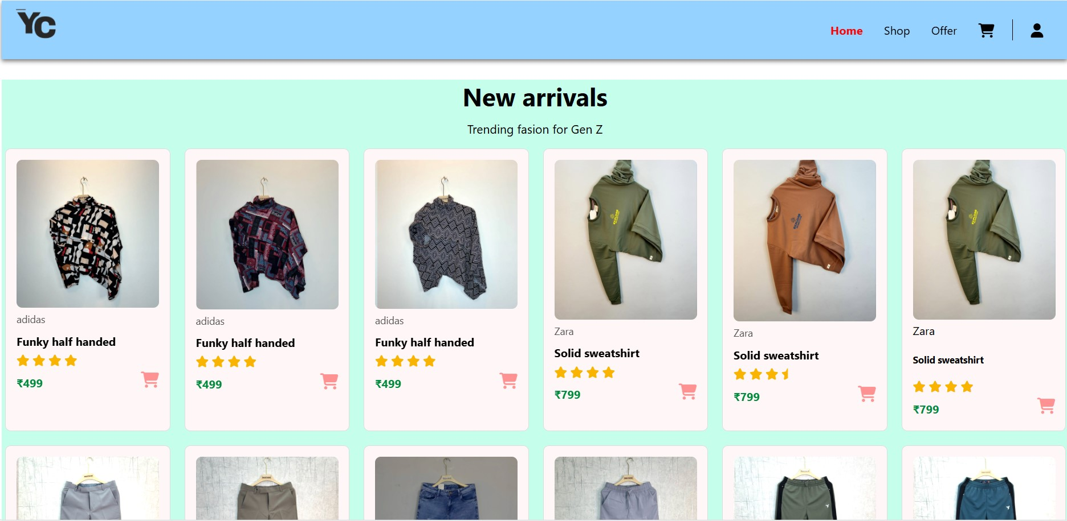


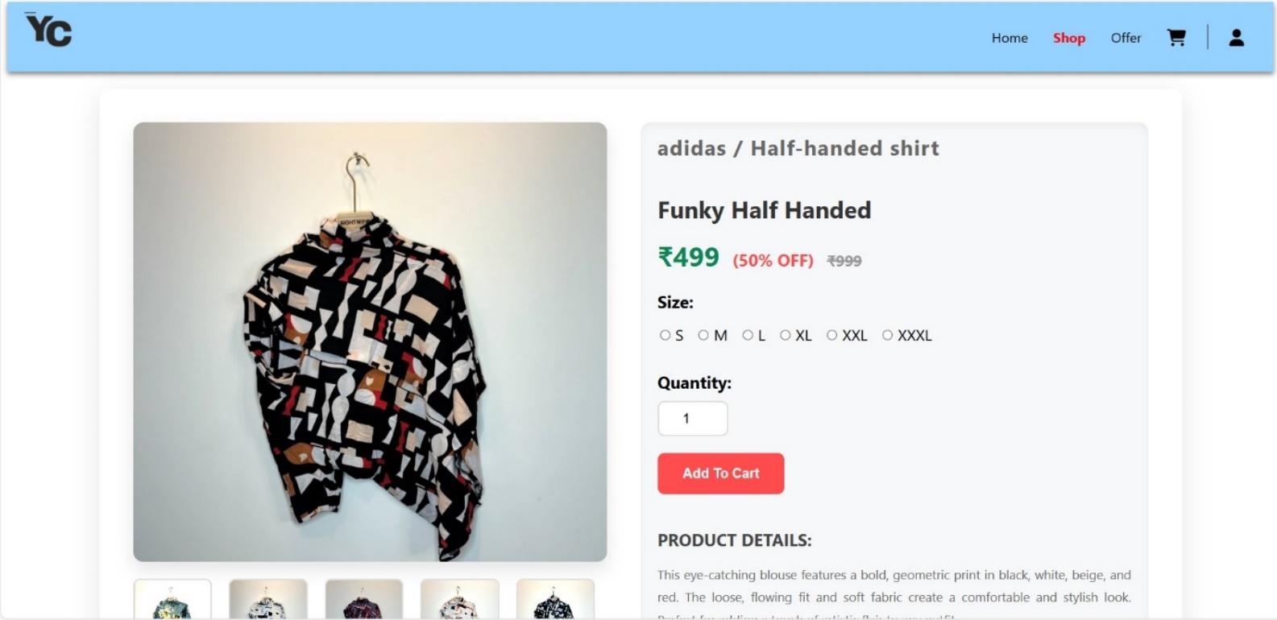
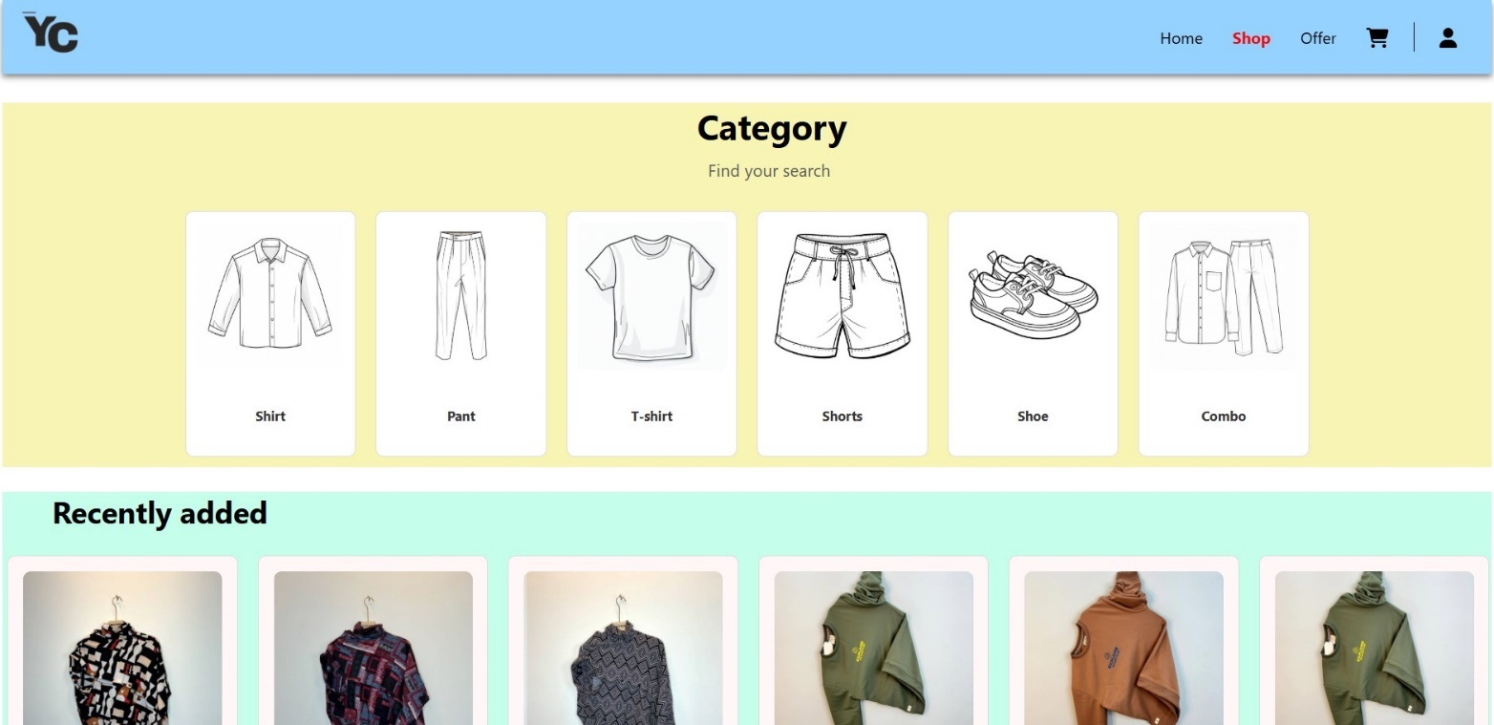
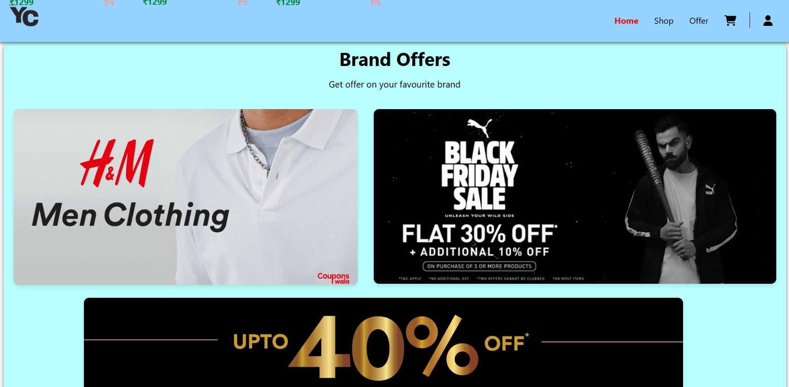
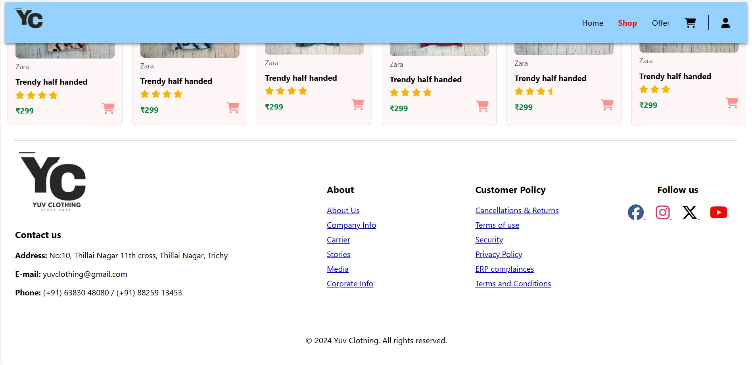
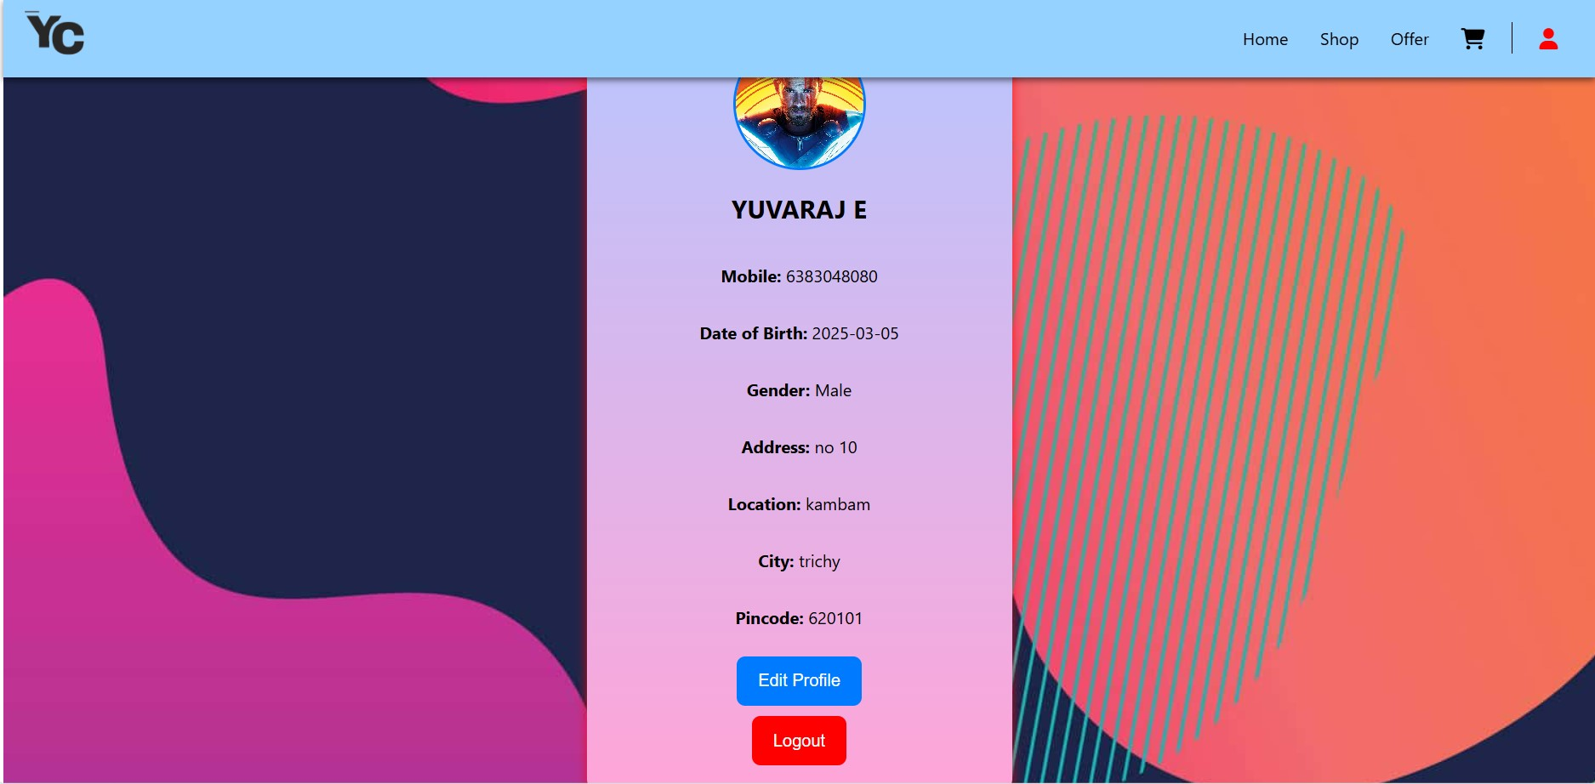
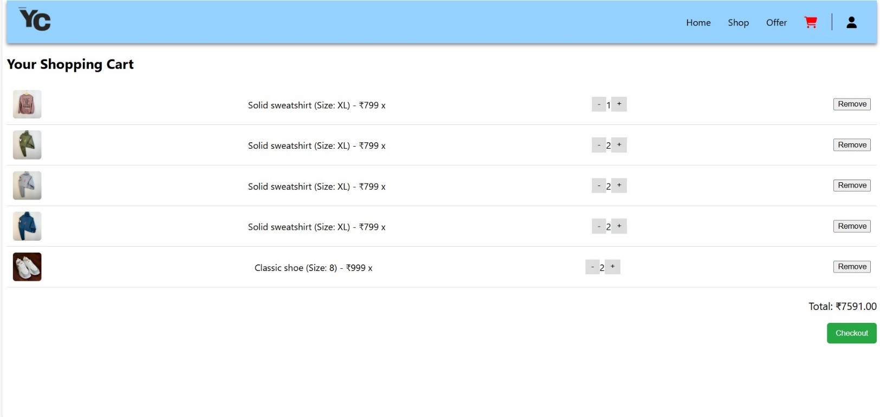
REFERNCES
- Adams, E. R., Peterson, J. T., & Ramirez, M. A. (2022). E-Commerce Strategies for Online Clothing Retail: A Case Study of Digital Transformation. Journal of Retail Management, 18(2), 145-162.
- Baker, C. L., Turner, A. B., & Hughes, L. R. (2021). Enhancing Customer Experience through AI-Driven Fashion Recommendations. International Journal of E-Commerce and Marketing, 14(4), 311-328.
- Clark, F. S., Harris, K. R., & Martinez, J. P. (2023). The Future of Online Clothing Retail: A Study on Consumer Behavior and Digital Adaptation. Journal of Digital Commerce, 17(1), 75-92.
- Gomez, M. H., Cooper, D. W., & Robinson, A. S. (2020). Integrating Augmented Reality for Virtual Try-Ons in Fashion E-Commerce. Journal of Retail Innovations, 8(3), 215-230.
- Jackson, B. R., Lee, S. L., & White, K. D. (2021). Data-Driven Insights: How Analytics Enhance Customer Engagement in Online Fashion. Fashion & Retail Research, 13(2), 183-200.
- Miller, E. L., Carter, H. R., & Davis, G. M. (2022). Security Measures in E-Commerce: Protecting Customer Data in Online Clothing Retail. Journal of Cybersecurity & E-Commerce, 9(4), 351-368.
- Perez, J. R., Turner, M. L., & Brown, N. A. (2023). Sustainable Fashion: Analyzing Consumer Preferences in Online Clothing Stores. International Journal of Sustainable Business, 21(1), 45-60.
- Rivera, S. D., Cooper, T. J., & Morris, E. W. (2020). Leveraging Technology for Personalized Shopping Experiences. International Journal of E-Retail, 11(3), 259-276.
- Simmons, G. A., Harris, L. B., & Walker, C. R. (2021). The Role of AI and Chatbots in Enhancing Customer Support for Clothing Websites. Journal of AI in Retail, 7(2), 129-146.
- Williams, M. E., Martinez, A. R., & Turner, S. L. (2022). E-Commerce Success Strategies: A Comparative Analysis of Fashion Retail Platforms. Journal of Digital Commerce Strategies, 16(4), 321-338.

Book References
- "E-Commerce Strategy, Technology, and Implementation" by Gary Schneider
- "Fashion Marketing and E-Commerce" by Margaret Bruce and Christopher Moore
- "Digital Retailing: Strategies for Omni-Channel Success" by Paul Doherty
- "The Art of Digital Marketing" by Ian Dodson
- "Mastering Shopify: Build and Customize Your Online Store" by Thomas F. Sheehan
- "Responsive Web Design with Bootstrap" by David Karlins
- "E-Commerce Website Optimization" by Alex Harris
- "Web Security for E-Commerce" by Kevin Beaver
- "Data-Driven Marketing: The 15 Metrics Everyone in Marketing Should Know" by Mark Jeffery
- "The Fashion Business Manual: An Illustrated Guide to Building a Fashion Brand" by Fashionary

Web References
- Shopify - Official website for building and managing online stores: shopify.com
- WooCommerce - E-Commerce platform for WordPress websites: woocommerce.com
- BigCommerce - Leading platform for enterprise-level online stores: bigcommerce.com
- W3Schools HTML & CSS - A popular resource for learning website development: www.w3schools.com/html/
- Bootstrap Documentation - Official Bootstrap guide for responsive web design: getbootstrap.com/docs/5.1/getting-started/introduction/
- Google Analytics - Official site for website analytics and traffic insights: analytics.google.com
- Moz SEO - Guide to search engine optimization for e-commerce websites: moz.com/learn/seo
- PayPal Developer - Information on integrating PayPal payments into e-commerce sites: developer.paypal.com
- Stripe API - Online payment solutions for businesses: stripe.com/docs
- Web Accessibility Guidelines - W3C official site for web accessibility standards: www.w3.org/WAI/

